**ie**

L. Durieux

Abstract

This guide explains how to order a fully assembled PCB from JLCPCB through a simple, three-step process: preparing the fabrication files, ordering components, and submitting the PCBA assembly. It aims to ensure a clear and reproducible workflow for the OCTAVie project.

JLCPCB PCBA Order Tutorial

English v1.0

Table of Contents

Part 1 – Preparing and Uploading the Fabrication Files 3

Step 1 – Access the PCB Assembly Ordering Page 3

Step 2 – Upload the Fabrication Files 3

Step 3 – Review the PCB Preview 3

Step 4 – Select PCB Assembly 4

Step 5 – Check the Bill of Materials (BOM) 5

Step 6 – Check the Component Placement (CPL) 5

Step 7 – Finalize File Submission 5

Part 2 – Ordering Components from JLCPCB 6

Step 1 – Access the JLCPCB Website 6

Step 2 – Navigate to the Parts Section 7

Step 3 – Search for Components 8

Step 4 – Check Availability and Stock 8

Step 5 – Add Components to Cart 9

Step 6 – Review Your Cart 9

Step 7 – Place the Order 10

Step 8 – Wait for Component Reception 10

Part 3 – Ordering the PCBA Assembly 11

Step 1 – Access the PCB Assembly Service 11

Step 2 – Review Component Matching 12

Step 3 – Check Placement (CPL File) 12

Step 4 – Finalize and Save to Cart 13

Step 5 – Proceed to Checkout 13

Step 6 – Wait for Production 13

License Information 14

Versioning 15

How to Order PCBA with JLCPCB

This document is part of a three-part tutorial series that explains how to place a PCBA (Printed Circuit Board Assembly) order with JLCPCB.

The complete workflow is divided into:

1. Preparing and exporting the fabrication files (Gerber + BOM + CPL). (to be completed later on in another document)

2. Ordering the components (treated this document).

3. Placing the PCBA assembly order once the components have been received by JLCPCB. (treated this document)

The objective of this guide is to provide a clear, step-by-step process, so that even users with little technical background can successfully reproduce the procedure.

# Part 1 – Preparing and Uploading the Fabrication Files

In this section, we explain how to prepare and upload the fabrication files that JLCPCB requires for PCB fabrication and assembly. These files describe the PCB layout and the placement of components, and they are mandatory before you can place an order for assembly.

## Step 1 – Access the PCB Assembly Ordering Page

Go to <https://jlcpcb.com/>. Log into your JLCPCB account and click on “quote now” of the 1-4 layers sub-windows.

## Step 2 – Upload the Fabrication Files

Click on 'Add your Gerber file' and upload the compressed archive (.zip) containing your design files. This archive should include the Gerber files et le Drill files. Note, that for all this project this archive will directly be available to you in the project file.

## Step 3 – Review the PCB Preview

After uploading, JLCPCB generates a visual preview of your board. Check that the board outline, copper layers, and drill holes are correct before proceeding. Note that all the right options will be added into JLC automatically. If you do not feel comfortable, leave them by default and it will work.

## Step 4 – Select PCB Assembly

If you do not feel comfortable to solder the component yourself, you choose pick select assembly PCB. The option by default are also adapted to this project.

If you feel comfortable assembling it yourself, it will be less expensive, and you will receive the board faster. In that case, you can select the stencil option. However, note that for the microphone, you will need a reflow oven to solder it, and even then, success is not always guaranteed.



For the purpose of this tutorial, we will proceed with the assembly option, as it is the most likely choice for users without prior experience.

## Step 5 – Check the Bill of Materials (BOM)

JLCPCB automatically parses the BOM file (the list of the components on the PCB). Note that the document for all PCB in the project will be available to you.

## Step 6 – Check the Component Placement (CPL)

Just like the BOM, you will also need to upload the Component Placement file, which indicates where the components should be placed on the board. Note that the documentation for all PCBs in the project will also be available to you.

## Step 7 – Finalize File Submission

Once the files have been verified, save the configuration to proceed to the next step. The project will then be available under **“My Project” -> “Quote”** on the JLCPCB website, allowing you to return to it later if needed. If you wish to continue immediately, you can proceed by completing the BOM directly. In cases where JLCPCB reports unavailable components, please refer to **Part 2 of this document**, which explains how to handle component sourcing.

# Part 2 – Ordering Components from JLCPCB

In this section, we will explain how to order the components required for your assembly. This step is mandatory before you can proceed with the PCBA order. JLCPCB requires that all components are stocked and available in their warehouse before the assembly service can begin.

## Step 1 – Access the JLCPCB Website

Open the JLCPCB website (https://jlcpcb.com) and log into your personal account. Make sure your account is active and that you can access the Parts section.

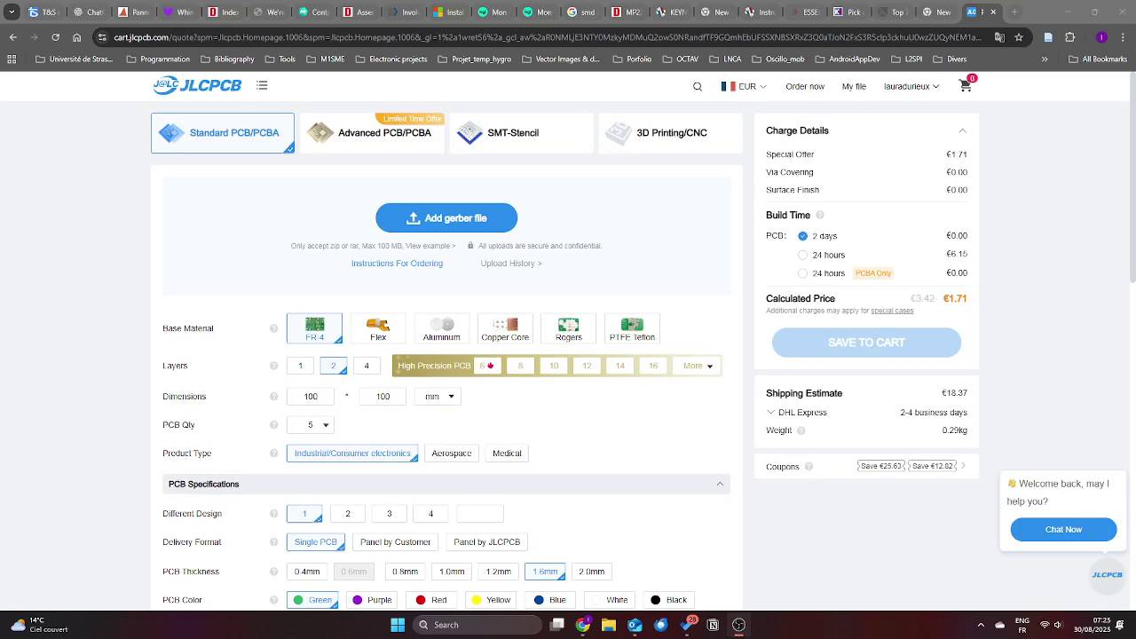

## Step 2 – Navigate to the Parts Section

In the top menu bar, click on 'Parts'. This section allows you to search for, select, and order the electronic components required for your design.

## Step 3 – Search for Components

Use the search bar to look for each part number listed in your Bill of Materials (BOM). Ensure that you use the correct manufacturer part number to avoid mistakes.

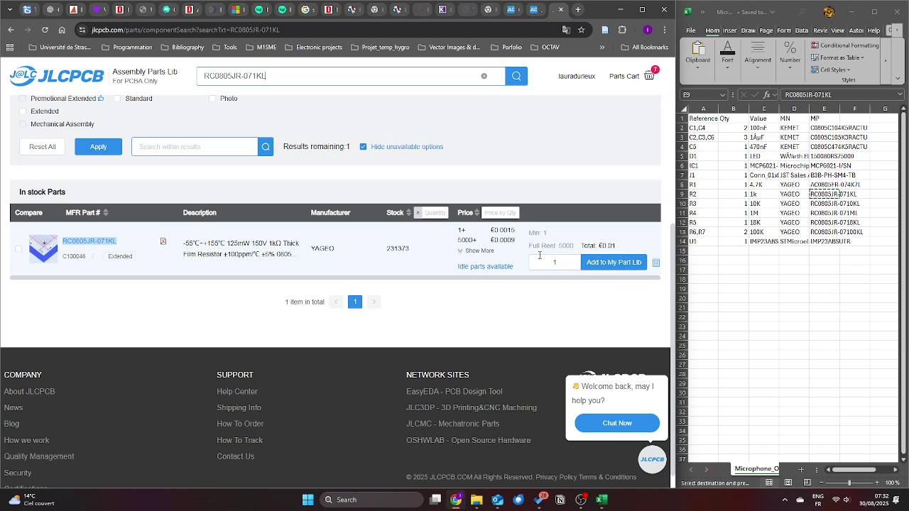

## Step 4 – Check Availability and Stock

Confirm that the required quantity is available in JLCPCB's stock. If a component is out of stock, you may need to select an alternative or adjust your order.

⚠️ Note: If the component is not directly available but listed in the database, you can request a quotation. For example, the MEMS microphone IMP23ABSUTR is sometimes not available in stock but can still be ordered through a quotation process. Be aware that this may significantly increase lead time.

## Step 5 – Add Components to Cart

For each part, specify the required quantity and add it to your shopping cart. Repeat this process for all the items in your BOM.

## Step 6 – Review Your Cart

Once all components have been added, open your cart to verify the correctness of part numbers, quantities, and availability. Double-check this step to prevent errors during assembly.

## Step 7 – Place the Order

Click on 'Proceed to Checkout' to finalize the order. Once the order is validated, JLCPCB will process and prepare your components.

## Step 8 – Wait for Component Reception

JLCPCB will handle the reception of components into their warehouse. Only after this step will you be able to continue with Part 3 of the tutorial and place your PCBA order.

# Part 3 – Ordering the PCBA Assembly

In this section, we explain how to place the PCBA (Printed Circuit Board Assembly) order with JLCPCB. This step can only be performed once your components have been received at JLCPCB’s warehouse (see Part 2). The process links your fabrication files with the stocked components to create the assembled boards.

## Step 1 – Access the PCB Assembly Service

Log into your JLCPCB account and go to the 'Quote & Order' section. Select 'PCB Assembly' to start a new order.

## Step 2 – Review Component Matching

JLCPCB automatically matches your BOM with components in stock. If you ordered components separately (Part 2), they are linked automatically once available in the warehouse.

## Step 3 – Check Placement (CPL File)

Verify the component placement preview carefully to ensure footprints, orientations, and positions are correct. Adjust if necessary.

## Step 4 – Finalize and Save to Cart

Once satisfied, review the order summary including PCB parameters, assembly options, and components. Save the order to your cart.

## Step 5 – Proceed to Checkout

Click 'Checkout' to confirm the order. This guide does not include payment details.

## Step 6 – Wait for Production

After confirmation, JLCPCB will manufacture and assemble your boards. You will receive a tracking number once the boards are shipped.

# License Information

**Hardware license**: CERN Open Hardware License v2 (Strongly Reciprocal – OHL-S).

**Software license**: GNU General Public License v3 (GPLv3), ensuring that all modifications remain open-source.

**Documentation license**: Creative Commons Attribution-ShareAlike 4.0 International (CC-BY-SA 4.0).

# Versioning

|  |  |  |  |
| --- | --- | --- | --- |
| Authors | Version | Date | Comment |
| L. Durieux | V1.0 | 26.09.25 | Document first release |
| L. Durieux | V1.0 | 0.5.10.2025 | Formatting |
|  |  |  |  |